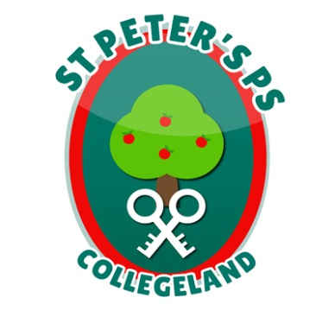
ST. PETER’S PRIMARY SCHOOL
90 Collegelands Rd
Charlemont
Moy
Co. Tyrone
BT71 6SW
Tel: 028 87 784620
Mob: 07860775105
Website: www.stpeterscollegeland.com 16th March 2020

‘Learning is Fun… Together as One’

Dear Parents/Guardians,

As always the health and wellbeing of our pupils, staff and wider community is our highest priority.

The school has taken the decision to utilise four days, outlined as closures in May and June 2020 (May 8th, 22nd and June 29th, 30th) in the school holiday list and move them to Wednesday, Thursday and Friday of this week as exceptional closures.

School will be closed for the remainder of this week.

We will continue to follow current guidance which as you are aware is being reviewed daily.

Initial “2 week learning packs” have been produced and will be ready for collection today between 12 and 3pm. We ask that parents exercise prudence in completing the home tasks, spreading the work out in a manageable way for the children.

Staff will work throughout the rest of the week to produce helpful materials for further home activities. Collection times for these will be arranged at a later date.

Updates will be communicated through the school website, text service and school facebook page.

We greatly appreciate all efforts on your behalf to help keep our children safe and are acutely aware of the challenges the current situation is placing on families.

We ask that you encourage the children to continue their daily prayers as they would in school for the wellbeing of everyone.

Regards Jim McAlinden

JimMcAlinden

Principal

