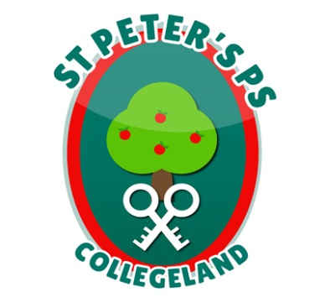
ST. PETER’S PRIMARY SCHOOL
90 Collegelands Rd
Charlemont
Moy
Co. Tyrone
BT71 6SW
Tel: 028 87 784620
Mob: 07860775105
Website: www.stpeterscollegeland.com 6th January 2022
‘Learning is Fun… Together as One’
Dear Parents,
We are delighted to welcome the children back to school and wish you all a very Happy New Year.

PE will continue with Mr McQuade on Fridays and we will have a second session of PE on Mondays starting in February with Mr Curran, in response to parental feedback.

The school believe that it is now time to extend the P1-3 teaching time so the children maximize their learning opportunities.

The new arrangements for P1-3 afternoon pick-up starting on Monday 10th January are as follows;

P1-3 Pick-up Plan PM
2.00 A-McA
2.05 McC-McK
2.10 McQ-W

Please communicate this change to family members collecting children.

We had minimum disruption to classes in Term 1, this was due to the safety procedures in school and the cooperation of you as parents and we ask for your continued support.

If pupils are symptomatic, parents should of course follow health advice on testing and not send pupils into school until cleared to do so by means of a negative Lateral Flow Test result.
The NI Executive has also announced a change to the rules on self-isolation for positive cases, reducing the period from 10 days to seven, providing the individual has negative LFD results on both days 6 and 7 with tests taken 24 hours apart. In all situations we ask that if your child is sick do not send them into school and let us know the circumstances by phone call. Specific Health advice for testing in the under-5s is available on NI Direct.
Yours sincerely
Jim McAlinden

