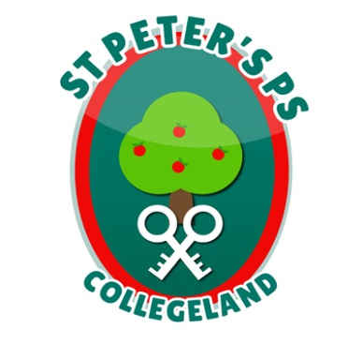
ST. PETER’S PRIMARY SCHOOL
90 Collegelands Rd
Charlemont
Moy
Co. Tyrone
BT71 6SW
Tel: 028 87 784620
Mob: 07860775105
Website: www.stpeterscollegeland.com 2nd March 2021
‘Learning is Fun… Together as One’
Dear Parents,

We are delighted to welcome the Primary 1,2 & 3 children back to school on Monday 8th March. The children are to be in school for two weeks (except St. Patrick’s Day) then going back to remote learning from Monday 22nd March. As you as you are aware decisions from the Executive can change at short notice and we will keep you updated of any changes to this current plan.
There will still be PE for children on Mondays and we ask that children wear their own PE clothes into school for this. School uniform should be worn the remainder of the week.

The arrangements for school reopening on Monday 8th March are as follows;
- Children in Primary 1,2 & 3 should attend school as normal.
- School meals will be available for children in Primary 1, 2 & 3. (All payments must be made on Mon 8th March for the 2 weeks)
- All adults bringing children to the school or collecting children MUST wear a face covering and adhere to social distancing.
- School packs will still be available for collection for children in P4 –P7 as before.
Key Worker/Vulnerable Children P4-7
- The school will continue to offer supervised learning.
- Key Worker/Vulnerable children should wear school uniform from Monday 8th March.
- Key Worker/Vulnerable children should continue to bring a packed lunch to school.
P1-3 Drop-off Plan AM
8.40 Group 1 A-McA
8.50 Group 2 McC-McK
9.00 Group 3 McQ-W

P1-3 Pick-up Plan PM
1.40 Group 2 A-McA
1.50 Group 3 McC-McK
2.00 Group 4 McQ-W

We are so glad to have the children back to school. We had minimum disruption to classes in Term 1. This was due to the safety procedures in school and the cooperation of you as parents.
If your child has symptoms do not send them to school and book a test.
If a member of your household is being tested do not send your child to school.
Yours sincerely
Jim McAlinden

